# PERSONALISED INVITATION USING CANVA/ WEDDING INVITATION

# INDRODUCTION :

**1.1overview**

## 

We Design a Personalised Invitation Using in Canva. It is the easiest way to use this project for our Team mates. Add a personal touch to the wedding invitation with a custom design in Canva. Choose the selection of beautiful layouts to create an invitation worthy of the auspicious occasion.

Download the PDF and PNG of the wedding invitation in stunning high resolution or share it on social media easily.

**1.2. PURPOSE**

We create a Personalised Invitation Using Canva in Wedding Card. We browse the canva library of beautiful and elegant wedding invitation layouts to find the perfect invitation for this project. Add the own images, fonts and colors to make easy, beautiful DIY wedding invitations on the canva homepage

# 2. Problems Definition&Design Thinking

## 

## 2.1 Empathy map

An empathy map is a collaborative visualization used to articulate what we know about a particular type of user.

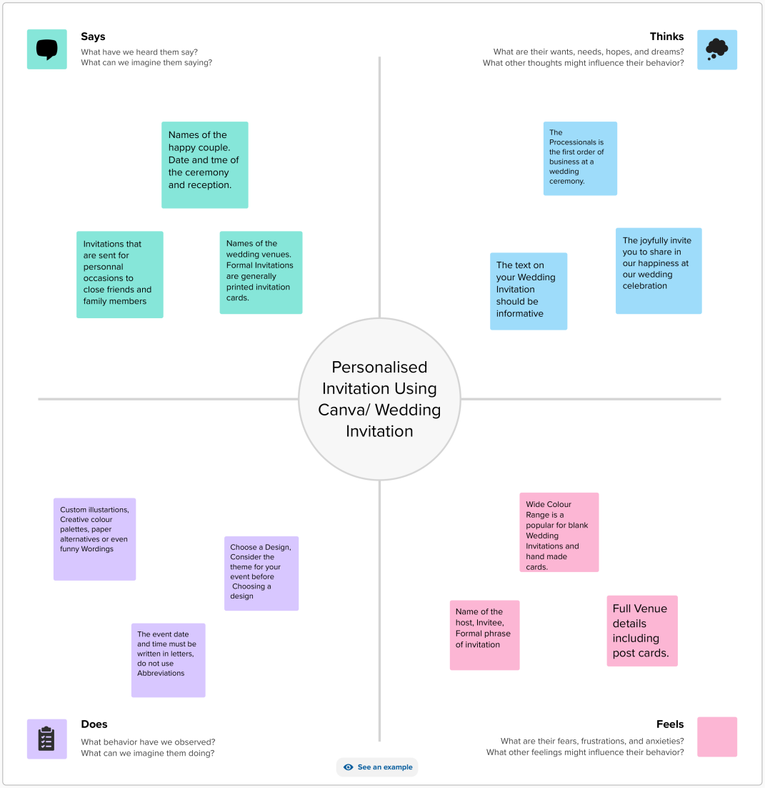

# 

# 2.2 Ideation & Brainstroming Map

A mind map is a visualization technique and brainstorming tool which allows you to explore a central idea, and all of its related topics, in a non-linear way.

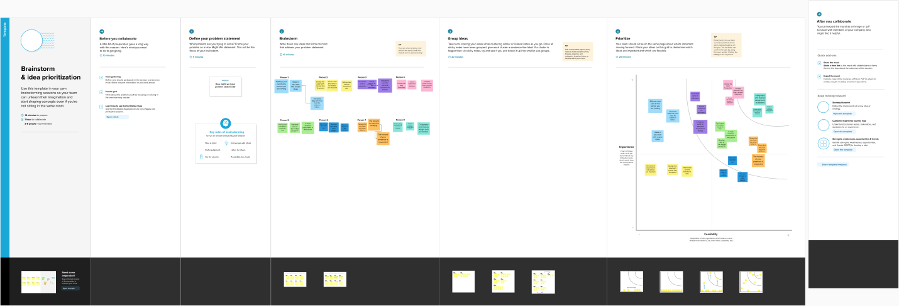

# 3. Result

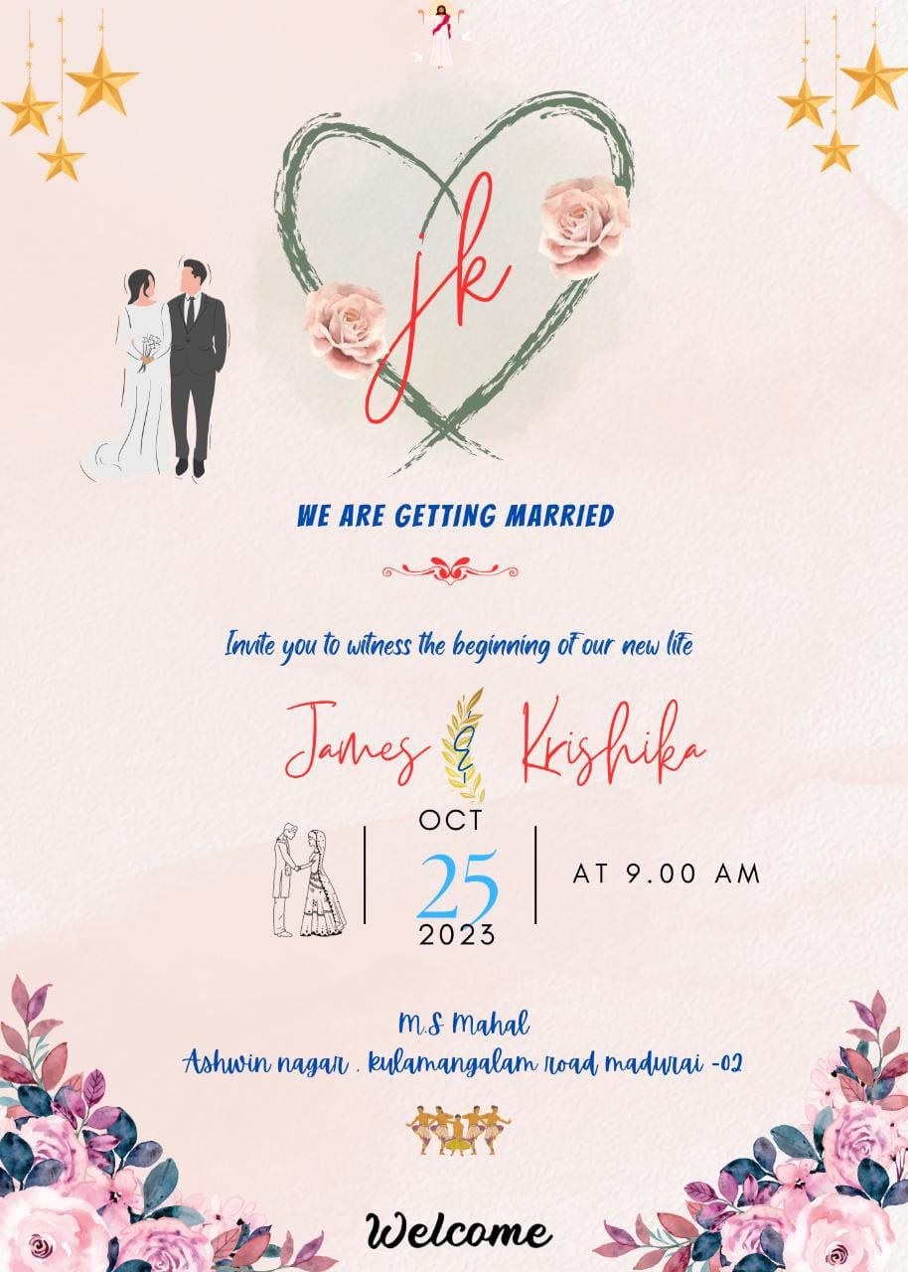

## 4 . ADVANDAGES AND DISADVANDAGES

Canva gives you access to over 1 million premium images, graphics and illustrations. Many of these images are free, while the rest are all offered at a very competitive price.

To add a personal touch, you can also upload your own images for free. Once you have saved them, you can use them as many times as you like.Freshers can easy to design anything in this canva . IT has many templates.

**5. APPLICATIONS:**

If you want to share your invitation electronically, simply click the Share button and choose from options such as sending your invitations via email or posting it directly to your social media accounts.

# 5. CONCLUSION

## We completed the Personalised Invitation Using canva. canva is the most useful and easy for the freshers . Beacause , It has many templates that was easy to use. Canva allows business to easily create designs that are consistent with their branding